Module-4 Automation Core Testing (Load Runner Up and Selenium IDE)

• **Which components have you used in Load Runner? **

* Load Generator generates the load against the application by following scripts.
* VuGen (Virtual User Generator) for generating and editing scripts.
* Controller controls, launches and sequences instances of Load Generator - specifying which script to use, for how long etc.

**• How can you set the number of Vusers in Load Runner? **

* You can set the number of Vusers in the controller section while creating your scenarios. Many other advanced options like ramp-up, ramp-down of Vusers are also available in the Controller section.

**• What is Correlation? **

* Correlation is a statistical measure that indicates the extent to which two or more variables fluctuate in relation to each other.

**• What is the process for developing a Vuser Script?**

* Step 1- Record the Vuser Script.
* Step 2- Playback and improve the recorded vuser script.
* Step 3- Define and test the different run-time parameters.
* Step 4- Use the script in a LoadRunner scenario.

**• How Load Runner interacts with the application?**

* LoadRunner simulates user activity by generating messages between application components or by simulating interactions with the user interface such as key presses or mouse movements. The messages and interactions to be generated are stored in scripts.

**• How many VUsers are required for load testing? **

* The test load used must be at least 100% and no more than 125% of the equipment's rated capacity unless otherwise recommended by the original equipment manufacturer (OEM). The weight itself should be certified prior to testing

**• What is the relationship between Response Time and Throughput? **

* Response time and throughput are related. The response time for an average transaction tends to decrease as you increase overall throughput. However, you can decrease the response time for a specific query, at the expense of overall throughput, by allocating a disproportionate amount of resources to that query.

**• What is the difference between hits/second and requests/second?**

* Hits per second means the number of hits the server receives in one second from the vuser. Request per second is the number of request the vuser will request from the server.

**• What is Automation Testing? **

* Automation testing is the process of testing software and other tech products to ensure it meets strict requirements

**• Which Are The Browsers Supported By Selenium Ide? **

* Selenium IDE has add-ons for Firefox and Chrome browsers. Selenium IDE comes with a rich set of commands that are powered by Selenese, and it allows you to record and test different interactions of a web application with the browser.

**• What are the benefits of Automation Testing? **

* Faster Feedback Cycle. ...
* Testing on Multiple Platforms in Parallel. ...
* Reusability of Test Scripts. ...
* Easy Data-driven Testing. ...
* Test Insights. ...
* Maximum Test Coverage. ...
* 24X7 Test Execution. ...
* Scalability.

**• What are the advantages of Selenium?**

* Very easy to use and install.

No programming experience is required, through knowledge of HTML and DOM are needed

* Can export tests to formats usable in Selenium RC and WebDriver
* Has built-in help and test results reporting module.
* Provides support for extensions

**• Why testers should opt for Selenium and not QTP? **

* Selenium supports Firefox, IE, Opera, Safari on operating systems like Windows,

Mac, Linux etc. however QTP is limited to Internet Explorer on Windows.

**• To validate the tops technologies website Contact us page and enter your friend detail at last “Guest Call Back” https://www.tops-int.com/contact-us/ **

**1. To use assert**

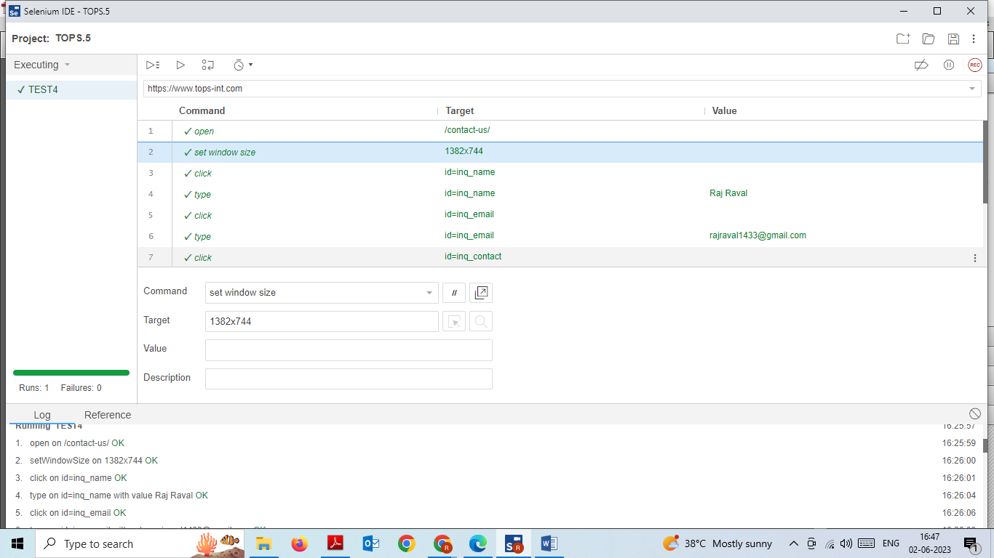

**2. To use click and wait**

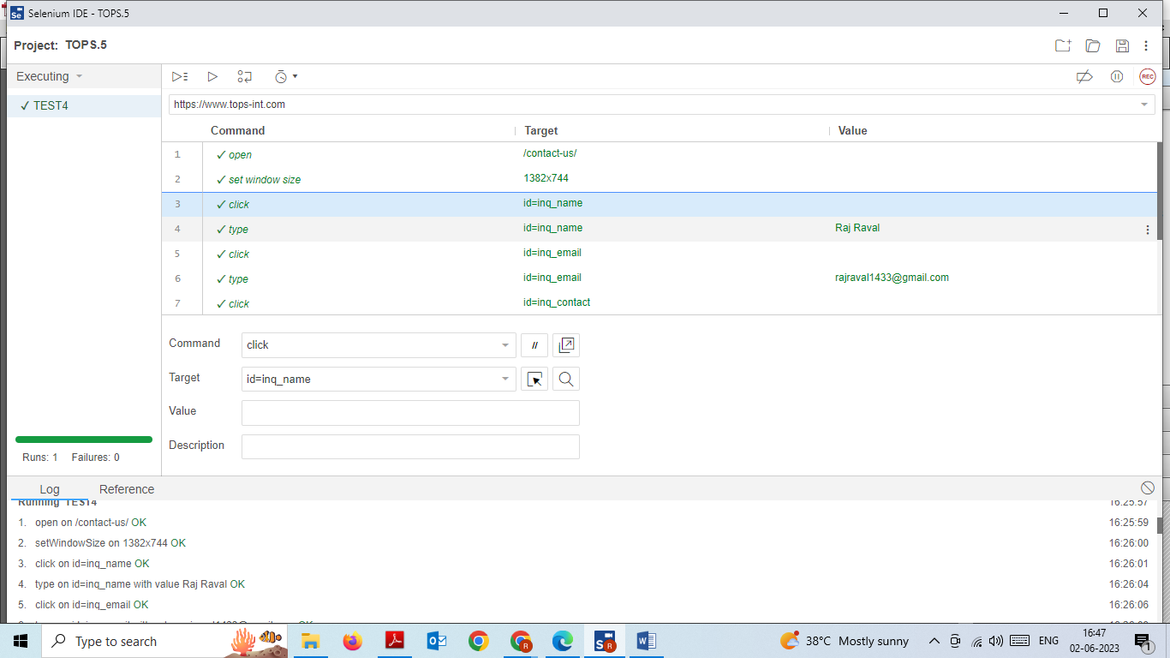

**3. To use locators**

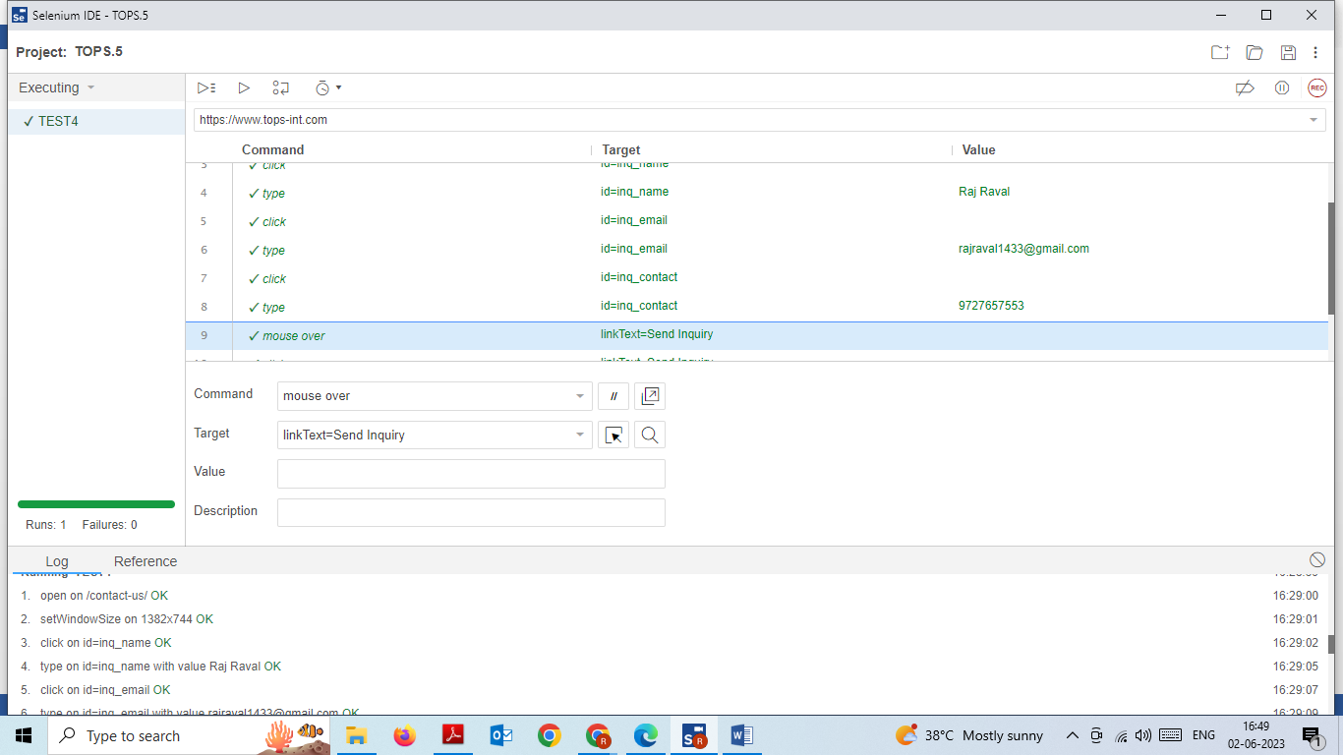

**4. To use other command**

